GRADE 10 BIOLOGY
ANATOMY AND PHYSIOLOGY OF ANIMALS
Nutrition in Animals
Study notes based on the supplied Grade 10 source chapter

Learning outcomes
- Relate the structure of insect mouthparts to their functions.
- Illustrate mouthparts of different insects.
- Relate the structure of bird beaks to their functions.
- Appreciate the diversity of feeding modes in insects and birds.

1. Introduction to nutrition in animals
Nutrition is the process by which an organism obtains and uses food substances for the maintenance of life processes.
A nutrient is a substance that provides essential materials for the maintenance of these processes.
Animals obtain nutrients by feeding on plants and other animals.
Insects and birds have different feeding habits. Their mouthparts and beaks are modified to enable them to obtain particular types of food.

2. Structure of insect mouthparts and their functions
The basic insect mouthparts comprise the labrum, mandibles, maxillae, labium and hypopharynx. These parts are modified differently according to the insect's mode of feeding.
The grasshopper represents the basic biting-and-chewing arrangement.
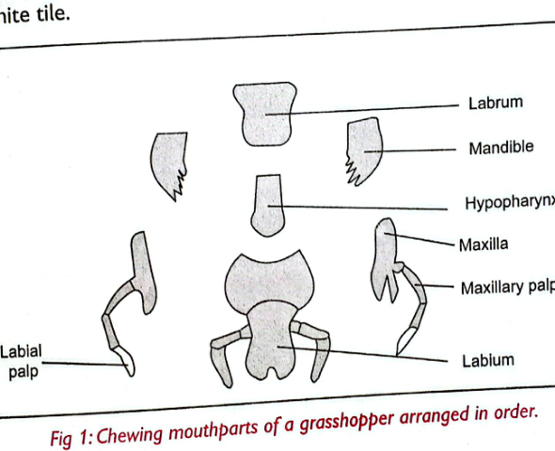
Figure 1: Chewing mouthparts of a grasshopper arranged in order.

Basic mouthparts
Part | Main structure/adaptation | Function
Labrum | Broad, lip-like structure at the front | Keeps food in the mouth.
Mandibles | Pair of strong jaws with sharp edges; move from side to side | Crush, grind, cut and chew food.
Maxillae | Pair of structures with maxillary palps | Manipulate food to ease chewing; palps are used for smell, touch and taste.
Labium | Flap-like back lip with labial palps | Keeps food in the mouth; palps are sensory structures involved in detecting/locating food by smell and taste.
Hypopharynx | Tongue-like structure between the maxillae; has a salivary duct | Mixes food with saliva and delivers saliva to the mouth.

3. Main feeding modes in insects
The basic insect mouthparts are modified to adapt insects to different feeding modes.

A. Biting and chewing
Used for biting and grinding solid food such as plant leaves.
- Examples: grasshoppers, locusts, cockroaches, dragonflies, termites, beetles, ants and crickets.
- Butterfly and moth larvae (caterpillars) also have biting-and-chewing mouthparts and mainly feed on soft plant material.
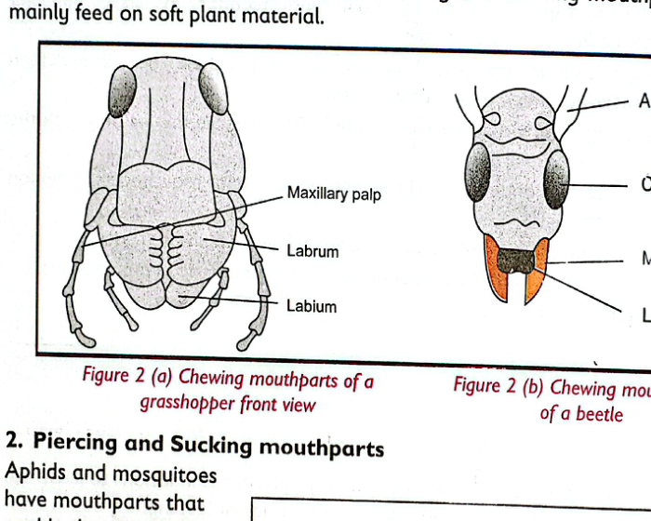
Figure 2: Chewing mouthparts of a grasshopper and a beetle.

B. Piercing and sucking
The mouthparts pierce the tissues of another organism and suck fluids from within.
- Mosquitoes pierce animal skin and suck blood.
- Aphids pierce plant tissues and suck plant sap.
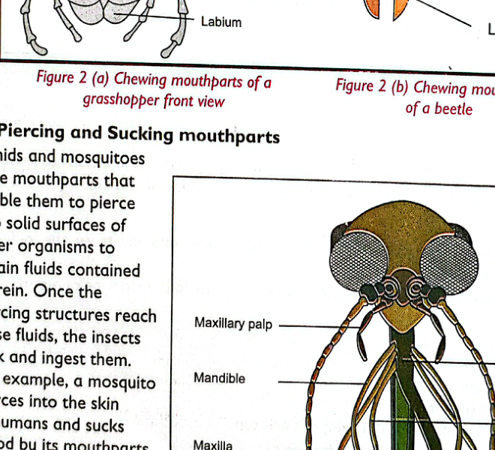
Figure 3: Piercing and sucking mouthparts of a mosquito.

C. Siphoning
Butterflies and moths have long, tube-like mouthparts called a proboscis. The proboscis is coiled and is used to siphon nectar from deep inside flower nectaries.
- Food obtained: mainly liquid nectar.
- The source also identifies bees among insects with siphoning/sucking mouthparts.
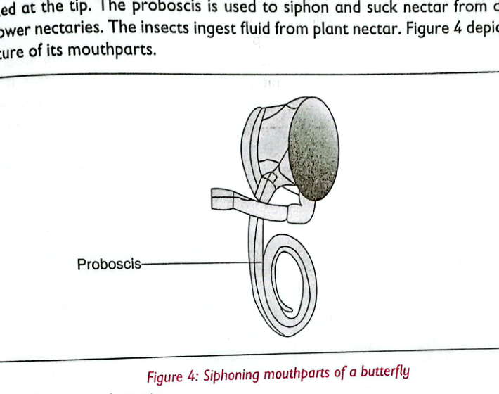
Figure 4: Siphoning mouthparts of a butterfly.

D. Cutting
Tsetse flies have cutting-and-sucking mouthparts used to obtain blood from vertebrate animals.
- The mouthparts pierce and cut the skin, then suck blood.
- The labium has teeth/structures used in piercing the host.
- The hypopharynx injects saliva into the blood to prevent clotting.
- Thecal bulb contains muscles that manipulate the mouthparts.
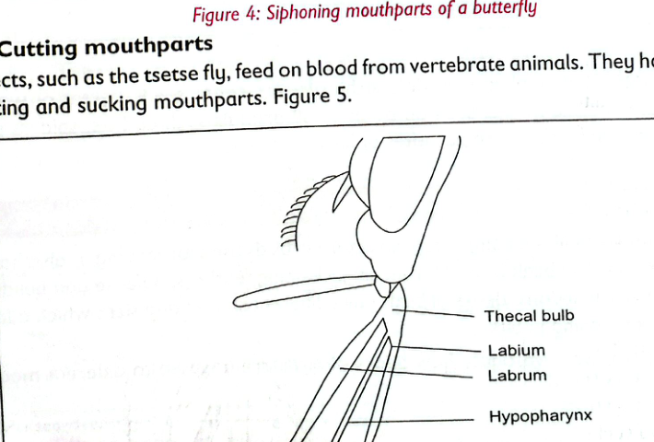
Figure 5: Cutting mouthparts of a tsetse fly.

E. Sponging / lapping
Houseflies have sponge-like mouthparts for taking up liquid food.
- A housefly can place saliva on solid food to dissolve it.
- The dissolved food is then taken up in liquid form by the sponging mouthparts.
- These are also called lapping mouthparts.
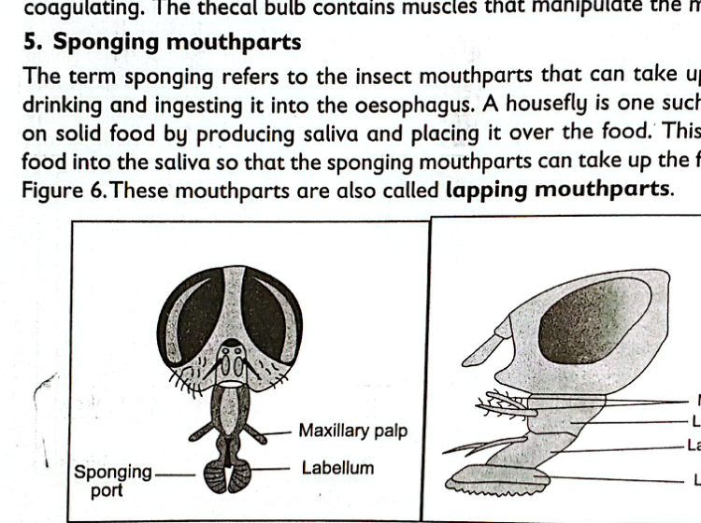
Figure 6: Sponging/lapping mouthparts of a housefly.

4. Structure of beaks of birds and their functions
A beak, or bill, is a bony mouth structure in birds used mainly for feeding. It also has a role in breathing, cleaning feathers, defence and nest building.
Bird beaks differ in size and shape because they are adapted to different feeding habits.
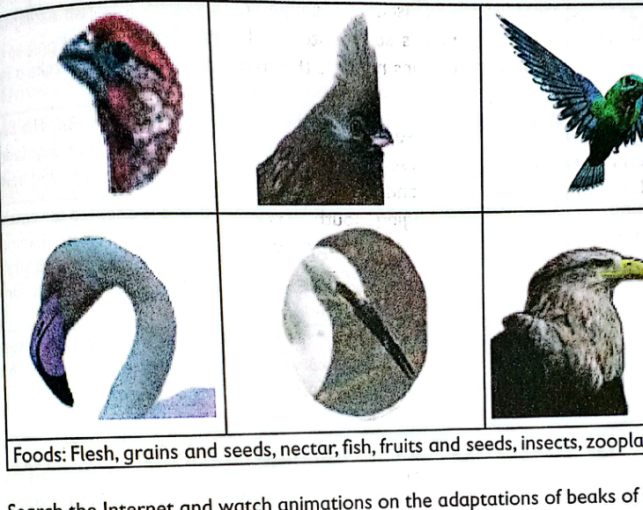
Figure 7: Examples of bird beaks shown in the source chapter.

Feeding modes and beak adaptations
Feeding mode | Beak adaptation | Function | Examples given
Grain and seed eating | Short, thick, cone-shaped beak; strong/hook-like upper beak | Cracks and crushes seeds | Domestic fowl, pigeons, parrots, sparrows, finches
Nectar feeding | Long, slender, pointed beak | Probes into flowers to obtain nectar | Sunbird, hummingbird
Filter feeding | Broad, flat beak | Scoops and strains food from water/mud | Flamingos, ducks
Fish eating | Long, sharp, pointed beak | Catches fish | Herons, cranes, seagulls, kingfishers, pelicans
Flesh eating | Short, sharp-edged, strong, hooked beak | Pierces, tears and rips flesh | Eagles, vultures, hawks
Insect eating | Small and wide beak, or long/slender slightly curved beak in some species | Catches flying insects or probes for larvae/pupae | Robins, kingbirds, hoopoe
Fruit eating | Sharp, large, curved and strong beak | Splits hard fruits, nuts and seeds | Parrots, hornbills
Special beaks: drilling | Long, straight, chisel-like beak | Drills bark/wood to obtain larvae and bugs | Woodpeckers
Special beaks: varied food | Long and thick beak | Holds and eats different foods | Toco toucan, Australian magpie

5. Importance of diversity in feeding modes
- Different feeding modes reduce competition for food where different species live together.
- Different adaptations enable organisms to access different types of food available in their habitats.
- Different feeding modes contribute to ecological interactions and survival.
- Some insects pollinate flowers, a process that leads to fertilisation in plants and formation of fruits that provide food for many organisms.
- Dung beetles and vultures feed on dead matter, helping to clean the environment.
- Diverse feeding modes enable organisms to live in different habitats and enhance their survival.

6. Quick comparison
Feeding mode | Key adaptation | Typical example
Biting and chewing | Strong jaws/mandibles | Grasshopper
Piercing and sucking | Piercing structures and fluid-sucking parts | Mosquito
Siphoning | Long coiled proboscis | Butterfly
Cutting | Cutting/piercing mouthparts | Tsetse fly
Sponging/lapping | Sponge-like labellum | Housefly

7. Revision questions
- Which insects exhibit: (a) biting and chewing, (b) piercing and sucking, (c) siphoning, and (d) lapping?
- Describe the structure and function of the mouthparts of a cockroach.
- Explain how the structure of a bird's beak is related to its feeding habit.
- State the importance of different feeding modes in insects and birds.
- Name the five basic mouthparts of an insect.
- Explain how a housefly obtains food from a solid food source.
- Distinguish between siphoning and piercing-and-sucking feeding modes.

8. Key terms
Entomology: The study of insects.
Proboscis: A long tube-like mouthpart used by insects such as butterflies to siphon liquid food.
Nectivorous: Feeding on nectar.
Filter feeding: Straining food from water using specialised mouth structures.
Sponging/lapping: Taking up liquid food using sponge-like mouthparts.
Feeding adaptation: A structural feature that enables an organism to obtain a particular type of food.
Source basis: uploaded Grade 10 chapter, pages 148–159. The diagrams in these notes are reproduced from the supplied pages.

