GRADE 10 BIOLOGY NOTES
Strand 2.3: Gaseous Exchange and Respiration in Plants
Compiled study notes with diagrams, practical/demonstration activities, observations and conclusions

Learning Outcomes
- Relate the structure of gaseous exchange sites in plants to their function
- Describe the mechanism of opening and closing of stomata in plants
- Investigate aerobic and anaerobic respiration in living organisms
- Explain the economic importance of anaerobic respiration in nature
- Appreciate the significance of gaseous exchange and respiration to plants and the environment

1. Introduction
Plants make organic compounds (e.g. glucose) by photosynthesis, and break these down by respiration to release energy for cellular activities.
Photosynthesis uses carbon (IV) oxide (CO₂) as a raw material and releases oxygen as a by-product. Respiration uses oxygen and releases CO₂ as a waste product. The passage of these two gases between a plant and its environment is called gaseous exchange.

Why plants do not have special gaseous-exchange organs (unlike animals)
- The vascular (transport) system of a plant does not carry gases, so every part of the plant meets its own gas needs.
- Plants are metabolically less active than animals, so they need much smaller volumes of gas.
- Large volumes of gas are only exchanged in the leaves, during photosynthesis.
- The diffusion distance inside a plant is short because most plant cells lie close to a gaseous exchange surface.
- Gases move from cell to cell by simple diffusion through cell walls and plasma membranes.

Meaning and significance of gaseous exchange
Gaseous exchange is the process by which respiratory gases move across a respiratory surface, driven by diffusion along a concentration gradient between the exchange site and the surrounding environment.
Significance to plants and the environment:
- Plants obtain CO₂ (needed for photosynthesis) and oxygen (needed for respiration) through gaseous exchange.
- Energy, water and CO₂ are the products of respiration; the energy drives other metabolic processes, while the CO₂ is re-used in photosynthesis during the day.
- At night, CO₂ that cannot be used in photosynthesis is released to the atmosphere through the gaseous exchange sites.
- By absorbing atmospheric CO₂, plants help offset the build-up of this greenhouse gas — a tree absorbs an average of 10 kg of CO₂ per year during its first 20 years, which is why planting trees helps address climate change.

A. Structure and Function of Gaseous Exchange Sites in Plants
Plants exchange gases at different sites depending on the part of the plant and its habitat. The main sites are: stomata (leaves), lenticels (woody stems/roots), cuticle (leaves/young stems) and pneumatophores (breathing roots of certain swamp plants). Aerenchyma tissue supports gaseous exchange in aquatic plants.

Practical Activity 1: Investigating the Release of Carbon (IV) Oxide by Fresh Leaves
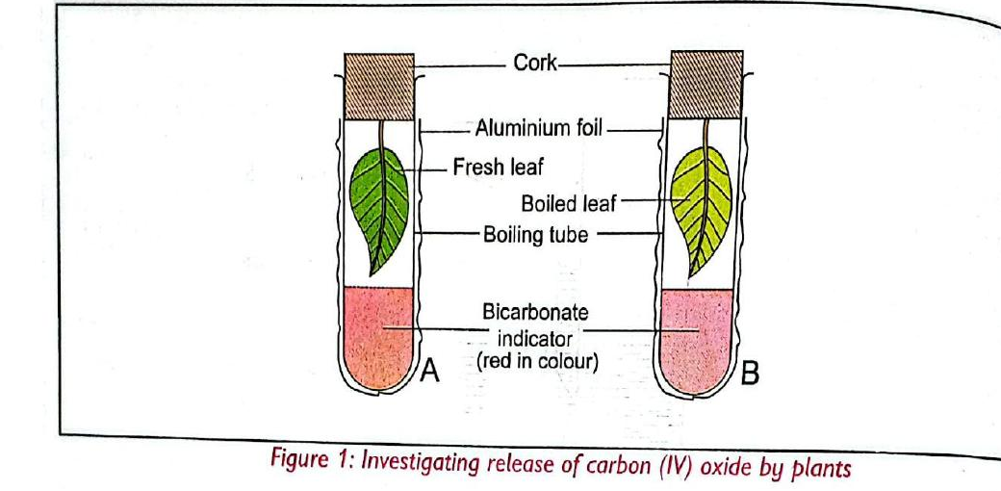
Figure 1: Set-up to investigate release of CO₂ by plants
Aim | To show that a fresh (living) leaf releases carbon (IV) oxide during respiration.
Requirements | Fresh leaves (one boiled, one fresh), two boiling tubes (A and B), dilute bicarbonate indicator, aluminium foil, thread, corks.
Procedure (summary) | Put 4 ml of bicarbonate indicator in each boiling tube. Wrap each tube in aluminium foil. Suspend a fresh leaf in tube A and a boiled leaf in tube B above the indicator using thread; cork both tubes. Leave for at least one hour, then remove the foil and observe the colour of the indicator.
Observation
  Boiling tube | Result
  A — fresh leaf | Red bicarbonate indicator turns yellow
  B — boiled leaf | Indicator remains red (no colour change)
Conclusion | The fresh leaf respired and released CO₂, which dissolved in the indicator, lowering its pH and turning it yellow (acidic). The boiled leaf's cells and enzymes were destroyed by heat, so no respiration occurred and the indicator stayed red. Aluminium foil excluded light so that photosynthesis (which would remove CO₂) could not mask the result.

Practical Activity 2: Investigating the Release of Oxygen by Plants
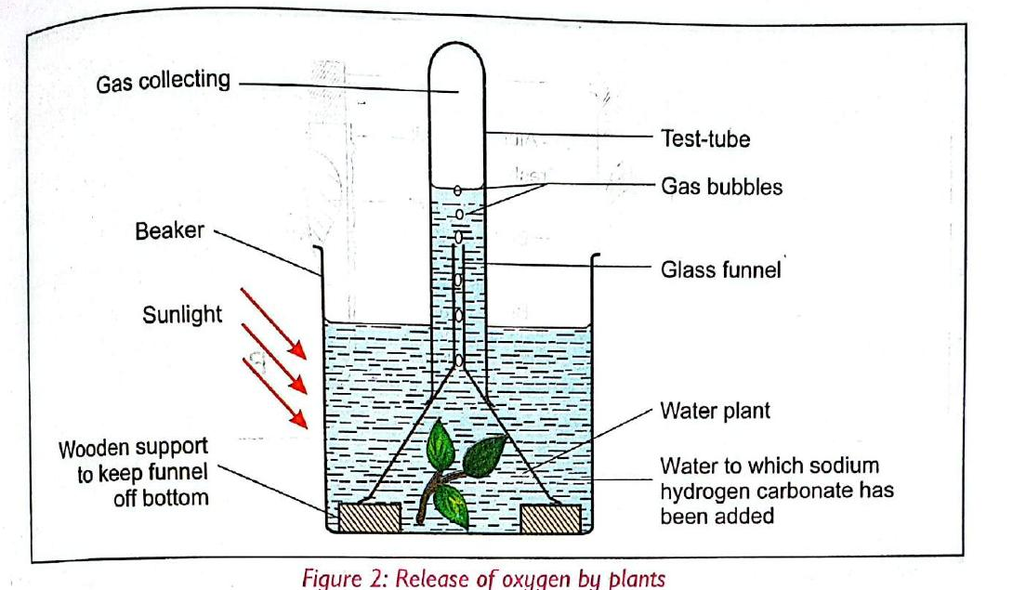
Figure 2: Set-up to investigate release of oxygen by a water plant
Aim | To show that a plant releases oxygen during photosynthesis.
Requirements | A water plant, glass funnel, beaker, boiling/test tube, wooden blocks, wooden splint, sodium hydrogen carbonate, water.
Procedure (summary) | Set up as in Figure 2: place the water plant under an inverted glass funnel in a beaker of water containing dissolved sodium hydrogen carbonate (to supply extra CO₂), with a water-filled test tube inverted over the funnel stem to collect gas. Place the set-up in sunlight until enough gas collects in the test tube, then test the gas with a glowing splint.
Observation | Gas bubbles collect in the inverted test tube. A glowing splint inserted into the collected gas re-lights (bursts into flame).
Conclusion | The gas collected is oxygen, produced as a by-product of photosynthesis by the water plant in the presence of sunlight. The re-lighting splint is the standard test confirming oxygen.

Adaptations of Gaseous Exchange Sites
Plants have different gaseous exchange sites depending on the medium of exchange: stomata (leaves), lenticels (woody stems and roots), cuticle, and pneumatophores (certain swamp/mangrove plants).

(a) Stomata
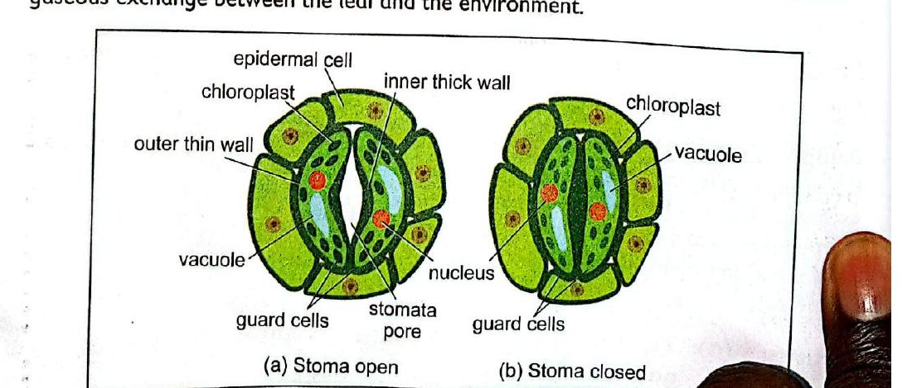
Figure 3: Stomata structure — (a) open stoma and (b) closed stoma
Activity | Peel the lower epidermis of a Bryophyllum/Tradescantia leaf, mount on a slide with water, stain with methylene blue, and observe under a light microscope (low then high power).
Observation | Tiny pores (stomata) are seen, each bordered by a pair of bean-shaped guard cells that (unlike other epidermal cells) contain chloroplasts.
Structure/Function notes | Guard cells occur in pairs; their outer wall (facing away from the pore) is thin and elastic, while the inner wall (facing the pore) is thick and less elastic. When guard cells become turgid, the thin outer walls stretch more than the thick inner walls, bowing outward and opening the stoma. Stomata occur mainly on the lower leaf surface, are more numerous where light is less direct, and generally open by day and close at night (though some plants show the reverse rhythm).
Conclusion | Stomata are the main gaseous exchange sites in leaves; their guard cells actively regulate the pore size to balance gaseous exchange against water loss.

(b) Lenticels
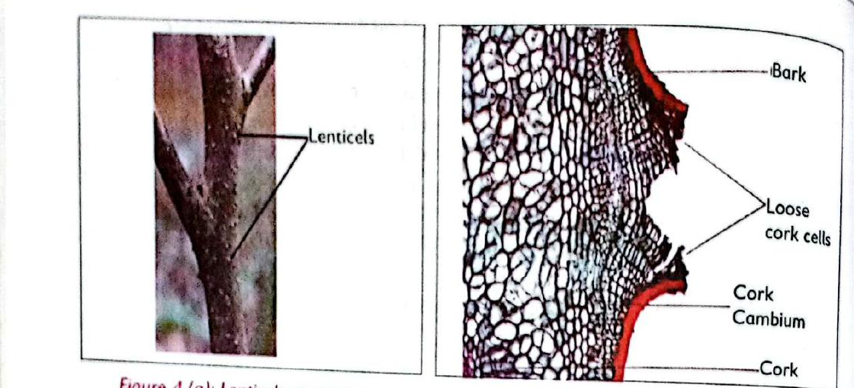
Figure 4: (a) Lenticels on a woody stem, (b) internal structure of a lenticel
Activity | Examine fresh woody stems with a hand lens, then observe a permanent slide of lenticels under a light microscope (low and medium power).
Observation | Lenticels appear as small, rough, cork-like raised spots/openings on the stem surface, made of loosely packed cork cells with visible air spaces between them.
Structure/Function notes | Unlike stomata, lenticels remain open at all times (they do not open/close). The loosely packed cork cells create large intercellular spaces that allow free diffusion of gases between the stem's interior and the atmosphere. Because respiration constantly uses up oxygen inside the stem, a concentration gradient is maintained that drives oxygen in and CO₂ out through the lenticels.
Conclusion | Lenticels are the main gaseous exchange sites on woody stems and roots, adapted by remaining permanently open with air-filled intercellular spaces.

(c) Pneumatophores
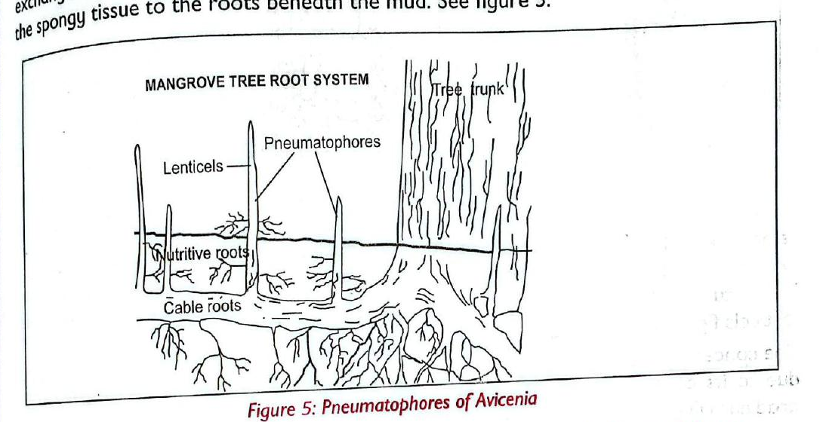
Figure 5: Pneumatophores of Avicennia (mangrove) root system
Activity | Observe photographs/charts of pneumatophores and draw a labelled diagram.
Observation | Upright, peg-like roots project above the muddy/waterlogged soil surface.
Structure/Function notes | Pneumatophores are specialised aerial (breathing) roots found in halophytes such as mangroves that grow in waterlogged, saline mud. They protrude above the mud to absorb atmospheric oxygen and have extensively developed aerenchyma tissue enclosing large air spaces. Small pores (lenticels) on their surface connect via air spaces to the roots buried in the mud, allowing gases to pass directly between the atmosphere and the submerged root system.
Conclusion | Pneumatophores adapt mangroves and similar plants to gaseous exchange in oxygen-poor, waterlogged mud by providing a direct air pathway from the atmosphere to the buried roots.

(d) Cuticle
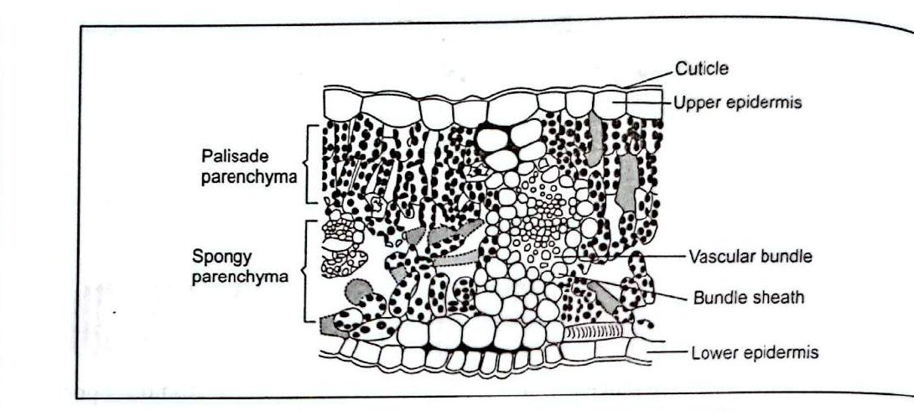
Figure 6: Transverse section of a leaf showing the cuticle
Activity | Peel a small portion of cuticle from a fleshy xerophyte leaf (e.g. sisal) using a surgical blade and observe with a hand lens.
Observation | A thin, transparent, waxy layer is peeled from the leaf surface.
Structure/Function notes | The cuticle is the outermost covering of leaves and young stems. In young plants it is thin, making it permeable enough to allow some gaseous exchange directly through it and the epidermis beneath. As the plant ages, the cuticle thickens and becomes impermeable. Submerged hydrophytes lack a cuticle altogether, so gaseous exchange occurs through their one-cell-thick epidermis, which shortens the diffusion distance.
Conclusion | A thin cuticle allows limited but useful gaseous exchange in young tissue; its thickening with age reduces this route (also reducing water loss).

(e) Aerenchyma
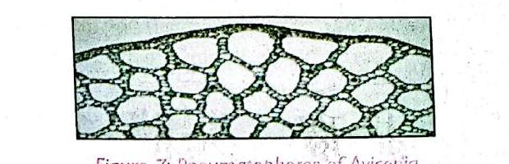
Figure 7: Aerenchyma tissue with large air spaces
Activity | Observe a permanent slide/photomicrograph of aerenchyma under a light microscope (low, then medium power).
Observation | Thin-walled cells enclosing large, irregular air spaces are seen.
Structure/Function notes | Aerenchyma is spongy tissue with large air spaces found in the leaves, stems and roots of aquatic plants. It enables plants to survive in low-oxygen environments such as wetlands, flood-prone areas and open water by storing air for gaseous exchange. The thin cell walls speed up diffusion of respiratory gases.
Conclusion | Aerenchyma is a key adaptation that lets aquatic and waterlogged-habitat plants store and exchange gases despite limited external oxygen.

B. Mechanism of Opening and Closing of Stomata
For gaseous exchange to occur, stomata must open. In most plants stomata open during the day and close at night, although some plants show a reversed rhythm. Three theories explain how guard cells control opening and closing: the photosynthetic theory, the starch–sugar interconversion theory, and the potassium-ion theory.

Comparison of the Three Theories
Theory | Basis | Daytime (stoma opens) | Night (stoma closes)
Photosynthetic theory | Glucose formation by chloroplasts in guard cells | Guard cell chloroplasts photosynthesise, producing glucose. Glucose is osmotically active, raising osmotic pressure in the guard cells, which absorb water by osmosis from adjacent epidermal cells, become turgid and bulge outward — the stoma opens. | In darkness, glucose is converted to starch (osmotically inactive), lowering osmotic pressure. Guard cells lose water by osmosis, become flaccid/plasmolysed, and the stoma closes.
Starch–sugar interconversion theory | Utilisation of CO₂ during photosynthesis, which changes guard-cell pH | Continuous use of CO₂ in photosynthesis raises guard-cell pH (less acidic). The higher pH favours conversion of starch to soluble sugar (glucose), which is osmotically active and draws water in by osmosis — guard cells become turgid and the stoma opens. | Without photosynthesis, CO₂ from respiration accumulates, lowering pH (more acidic). Low pH favours conversion of glucose back to starch, which is osmotically inactive; guard cells lose water, become flaccid, and the stoma closes.
Potassium-ion theory | ATP formation during photosynthesis driving active transport of K⁺ ions | Light-driven ATP production supplies energy for active transport of potassium ions from epidermal cells into the guard cells (with H⁺ moving out). Accumulated K⁺ raises osmotic pressure; guard cells absorb water by osmosis, become turgid, and the stoma opens. | ATP levels fall, so there is no energy to drive K⁺ uptake. Potassium ions diffuse out of the guard cells (H⁺ moves in), osmotic pressure falls, guard cells lose water, become plasmolysed, and the stoma closes.

Distribution of Stomata in Different Habitats
Based on habitat and water availability, plants are grouped as xerophytes (dry habitats), mesophytes (habitats with adequate water), hydrophytes (aquatic habitats) and halophytes (saline habitats).

Xerophytes
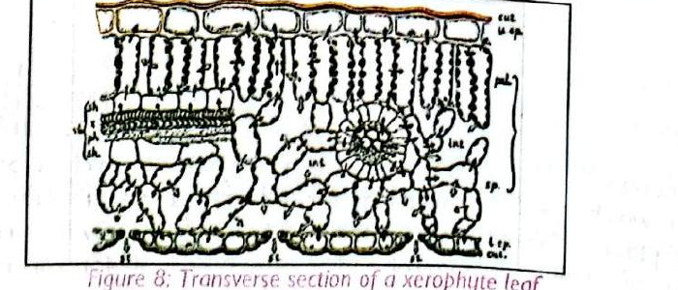
Figure 8: Transverse section of a xerophyte leaf
Xerophytes are adapted to arid/semi-arid habitats. They generally have fewer, smaller stomata than mesophytes, located mainly on the lower leaf surface. In some xerophytes stomata are sunken in pits/grooves, and in others stomata open at night and close (or only partially open) during the day. These adaptations reduce water loss by transpiration and evaporation while still permitting gaseous exchange.

Mesophytes
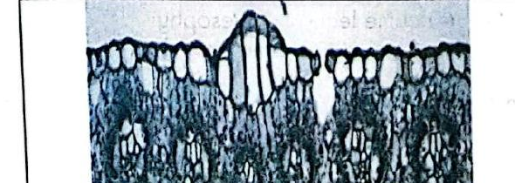
Figure 9: Transverse section of a mesophyte leaf
Mesophytes grow where water supply is adequate. They have a fairly large number of medium-sized stomata, distributed in roughly equal numbers on both leaf surfaces.

Hydrophytes
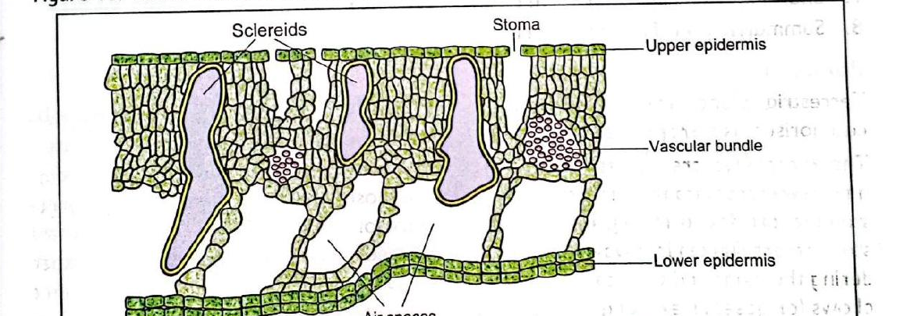
Figure 10: Transverse section of a hydrophyte leaf
Hydrophytes are aquatic plants (some, like Nymphaea/water lily, are not fully submerged). They have many large stomata, mostly on the upper leaf surface (exposed to air), which also help release excess water to the atmosphere. Hydrophytes possess aerenchyma tissue with large air spaces for gaseous exchange and buoyancy, and their stems/leaves have little or no lower cuticle.

Practical Activity 3: Comparing Stomatal Distribution in Different Habitats
Aim | To observe and compare the number, size and distribution of stomata on leaves of xerophytes, mesophytes and hydrophytes.
Requirements | Fresh leaves of a xerophyte, a mesophyte and a hydrophyte (or permanent slides/photomicrographs), light microscope, methylene blue, hand gloves.
Procedure (summary) | Peel the upper epidermis of each leaf type, stain with methylene blue, mount and observe under low power; count and record the number of stomata visible and estimate stoma size. Repeat for the lower epidermis of each leaf type.
Observation (record in a table)
  Leaf of | Stomata: upper | Stomata: lower | Stoma size
  Xerophyte | Few / none | Few, small, sunken | Small
  Mesophyte | Moderate | Moderate (~equal) | Medium
  Hydrophyte | Many, large | Few or none | Large
Conclusion | Stomatal number, size and distribution differ according to habitat: hydrophytes show most stomata on the upper (exposed) surface for gaseous exchange in an aquatic environment; xerophytes have the fewest, smallest stomata (often on the lower surface) to conserve water; mesophytes are intermediate, with stomata fairly evenly distributed on both surfaces.

C. Aerobic and Anaerobic Respiration in Living Organisms
Living organisms need a constant supply of energy from food substances (taken in by animals, or manufactured by photosynthesis in plants). This energy is released through respiration, which may be aerobic or anaerobic. Energy is released gradually in small amounts (not all at once) to avoid “burning” the cells.

Aerobic Respiration
Aerobic respiration breaks down food substances such as glucose completely, in the presence of oxygen, to release energy, water and CO₂. It occurs in the mitochondria (and cytoplasm) of plant and animal cells and releases a large amount of energy.
Glucose + Oxygen → Carbon (IV) Oxide + Water + Energy
C₆H₁₂O₆ + 6O₂ → 6CO₂ + 6H₂O + Energy (ATP)

Anaerobic Respiration
Anaerobic respiration breaks down glucose without using oxygen, in the cytoplasm. Breakdown is incomplete: in plants, an intermediate compound, ethanol, is produced instead of full breakdown to CO₂ and water, so much less energy is released than in aerobic respiration.
Ethanol is poisonous and plant tissue can only respire anaerobically for a short time. This process happens naturally in grapes fermenting on the vine, and in organisms such as bacteria and yeast, which can survive without oxygen — yeast is exploited commercially for alcoholic fermentation. Anaerobic respiration is therefore also called fermentation; alcoholic fermentation is the breakdown of simple sugars by yeast into energy, CO₂ and ethanol.

Practical Activity 4: Investigating Aerobic Respiration in Germinating Seeds
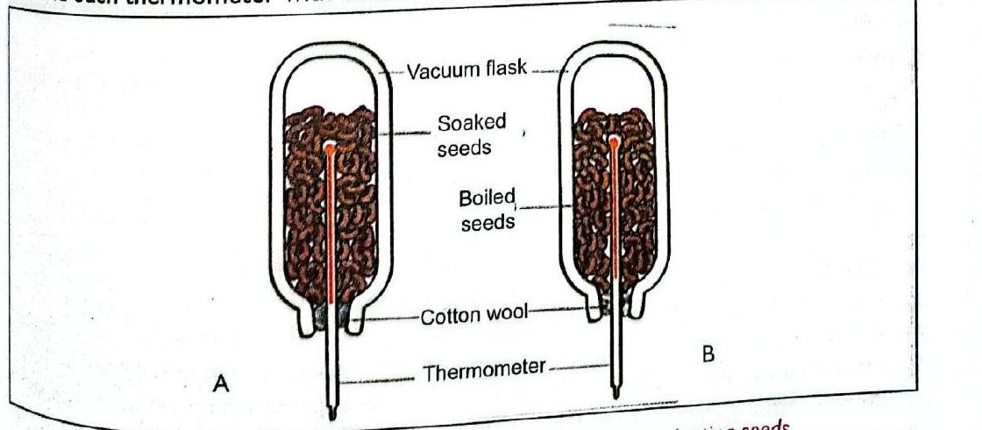
Figure 11: Set-up to investigate aerobic respiration in germinating seeds
Aim | To show that germinating (respiring) seeds release heat energy through aerobic respiration.
Requirements | Soaked bean seeds, boiled bean seeds (washed in 10% methanol), two vacuum flasks (A and B), two thermometers, cotton wool, retort stand.
Procedure (summary) | Half-fill flask A with soaked (living) bean seeds and flask B with boiled bean seeds. Insert a thermometer into each flask, bulb surrounded by seeds, and hold it in place with cotton wool. Record the initial temperature, then record the temperature every morning for one week.
Observation
  Flask | Result over one week
  A — soaked (living) seeds | Temperature rises steadily
  B — boiled seeds | Temperature stays about the same (no significant rise)
Conclusion | The living seeds in flask A respired aerobically, releasing heat energy that raised the flask's temperature. The boiled seeds in flask B had their enzymes denatured by heat, so no respiration (and no heat release) occurred. Methanol was used to kill micro-organisms on the boiled seeds so that microbial respiration would not affect the result. The vacuum flask minimises heat loss, and cotton wool allows diffusion of O₂ in and CO₂ out while sealing the flask.

Practical Activity 5: Investigating Anaerobic Respiration in Yeast
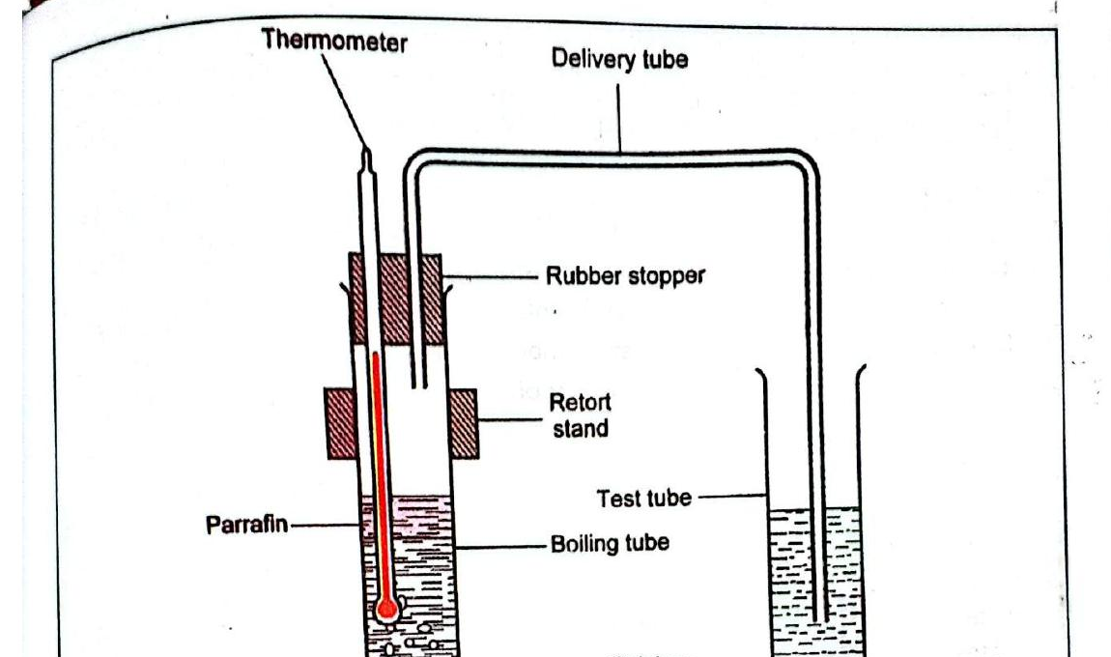
Figure 12: Set-up to investigate anaerobic respiration in yeast
Aim | To show that yeast can respire anaerobically, releasing energy, CO₂ and ethanol without oxygen.
Requirements | Glucose solution, yeast, calcium hydroxide solution, thermometer, oil/kerosene, delivery tube, rubber stopper, retort stand, source of heat, stop-watch.
Procedure (summary) | Boil 20 ml of glucose solution (to expel dissolved oxygen), cool to 40°C and add yeast. Add a layer of oil/kerosene on top of the suspension to keep out air. Connect the boiling tube (glucose + yeast) via a delivery tube to a test tube containing calcium hydroxide solution. Insert a thermometer into the suspension and record the initial temperature. Leave the set-up for 30 minutes, then record the final temperature and observe the calcium hydroxide solution.
Observation
  What was observed | Result
  Thermometer reading | Rises over the 30 minutes
  Calcium hydroxide solution | Turns milky/cloudy — white precipitate forms
Conclusion | The oil layer excluded oxygen, so the yeast respired anaerobically, breaking down glucose into ethanol, CO₂ and energy. The heat released raised the thermometer reading. The CO₂ produced passed through the delivery tube and reacted with the calcium hydroxide to form insoluble calcium carbonate, seen as a white precipitate — confirming CO₂ was produced. Boiling the glucose solution beforehand ensured only anaerobic respiration occurred.

Table 1: Differences between Aerobic and Anaerobic Respiration
Aerobic Respiration | Anaerobic Respiration
Oxygen is necessary for the process to take place. | Oxygen is not required.
A high amount of energy is released, so it is an efficient way of obtaining energy. | Low amounts of energy are released, so it is an inefficient method of obtaining energy.
The substrate (glucose) is completely broken down to CO₂, water and energy. | There is incomplete breakdown of the substrate, resulting in ethanol, CO₂ and energy.
Occurs in both the cytoplasm and the mitochondria. | Occurs only in the cytoplasm.

D. Economic Importance of Anaerobic Respiration in Nature
Human beings have long applied knowledge of anaerobic respiration (fermentation) in many fields of everyday life and industry:
Field | Application of Anaerobic Respiration
Brewing industry | Yeast anaerobically breaks down sugar in sorghum, barley, malt and grapes to make alcoholic beverages (wines, beers). Distilling the alcohol produced yields power alcohol, used as a substitute for petrol in vehicles.
Baking industry | Yeast produces CO₂ which causes dough to rise, making it possible to bake bread and cakes.
Dairy industry | Bacteria anaerobically break down sugars in milk to release lactic acid, enabling production of cheese, cream, butter, ghee and yoghurt.
Sewage treatment | Micro-organisms anaerobically break down organic matter and reduce sludge volume, producing effluent with reduced suspended solids.
Biogas production | Micro-organisms anaerobically break down organic matter in sealed tanks to produce biogas (CO₂ and methane); the methane is collected and used as fuel for cooking or heating.
Production of organic acids | Bacteria anaerobically break down ethanol to produce organic acids such as ethanoic (acetic) acid, citric acid, oxalic acid and butanoic acid.
Pharmaceutical industry | Anaerobic respiration is used to produce drugs such as penicillin.
Agriculture | Micro-organisms anaerobically break down sugars in forage material, producing acids (e.g. acetate, lactate) that lower pH and inhibit decomposers, preserving forage used in livestock feeding (silage-making).

Summary
- Gaseous exchange is the diffusion of respiratory gases (O₂ and CO₂) between plant tissues and the environment across a respiratory surface.
- Main gaseous exchange sites: stomata (leaves — open/close via guard cells), lenticels (woody stems/roots — always open), cuticle (thin in young tissue), pneumatophores (breathing roots of mangroves/swamp plants), and aerenchyma (air-storage tissue in aquatic plants).
- Three theories explain stomatal opening/closing: photosynthetic theory, starch–sugar interconversion theory, and potassium-ion theory — all link daytime energy capture to guard cells becoming turgid (open) and night-time reversal to guard cells becoming flaccid (closed).
- Stomatal number, size and distribution vary with habitat: xerophytes (few, small, often lower surface), mesophytes (moderate, both surfaces), hydrophytes (many, large, mainly upper surface).
- Respiration releases energy from food: aerobic respiration (with O₂) is efficient and complete, occurring in mitochondria and cytoplasm; anaerobic respiration (without O₂) is inefficient and incomplete, occurring only in the cytoplasm, producing ethanol in plants.
- Anaerobic respiration (fermentation) has wide economic importance: brewing, baking, dairy, sewage treatment, biogas production, organic acid production, pharmaceuticals and agriculture (silage).

